Team Name: Team Name 2026

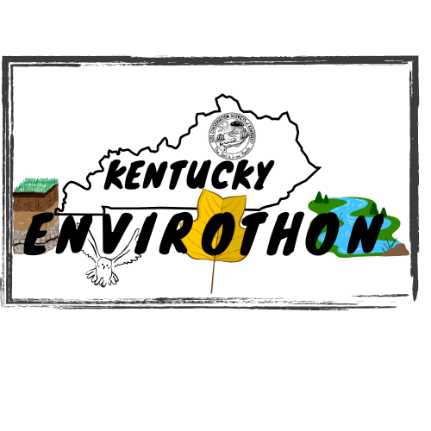
.

Participant’s Name (please print): Participant’s name
Parent’s Name (please print): Parent’s name

I hereby grant permission for my child to participate in the 2026 Envirothon Competition. I realize that this event may be strenuous, and that adverse weather conditions may occur. Nevertheless, I wish for my child to participate and hereby assume the risk involved.
I certify that my son/daughter is in good health and he/she is able to participate in this event. I authorize the Kentucky Envirothon program to provide emergency medical attention for my child during this event. I have been assured that all reasonable care will be taken to prevent incident, therefore I will not hold Kentucky Envirothon liable should an accident occur.
I fully understand the scope of this activity and voluntarily sign this form.

Team Name: Team Name 2026

MEDICAL
INFORMATION

Please Print
Participant’s Full Name: Participant Full Name

Parent/Guardian’s Name: Parent/Guardian Name

Address: Address (street, city, state, zip

Telephone: Telephone number

Person to contact in case of emergency: Emergency contact

Contact Person’s Phone Number: Emergency contact phone number

Insurance Carrier: Insurance carrier Policy #: Insurance policy number

Allergies (medication, food, etc.) Allergies

Medications currently being taken: Current medications

Person completing form: Person completing form
Team Name: Team Name 2026

PHOTO RELEASE

Please Print
Participant’s Full Name: Participant’s full name

Parent/Guardian’s Name: Parent/Guardian’s name

Telephone: Telephone

I hereby consent to the use of this photograph of my child/dependent/self, and/or any copies of this photograph in any editorial and/or promotional material produced and/or published by the Kentucky Envirothon.

